Java LAB-1 Program

Q1)Develop a java program that prints all real solutions to the quadratic equation ax^2+bx+c=0.Read in a,b,c and use the quadratic formula.If the discriminant b^2-4ac is negative,display the message stating that there are no real solutions.

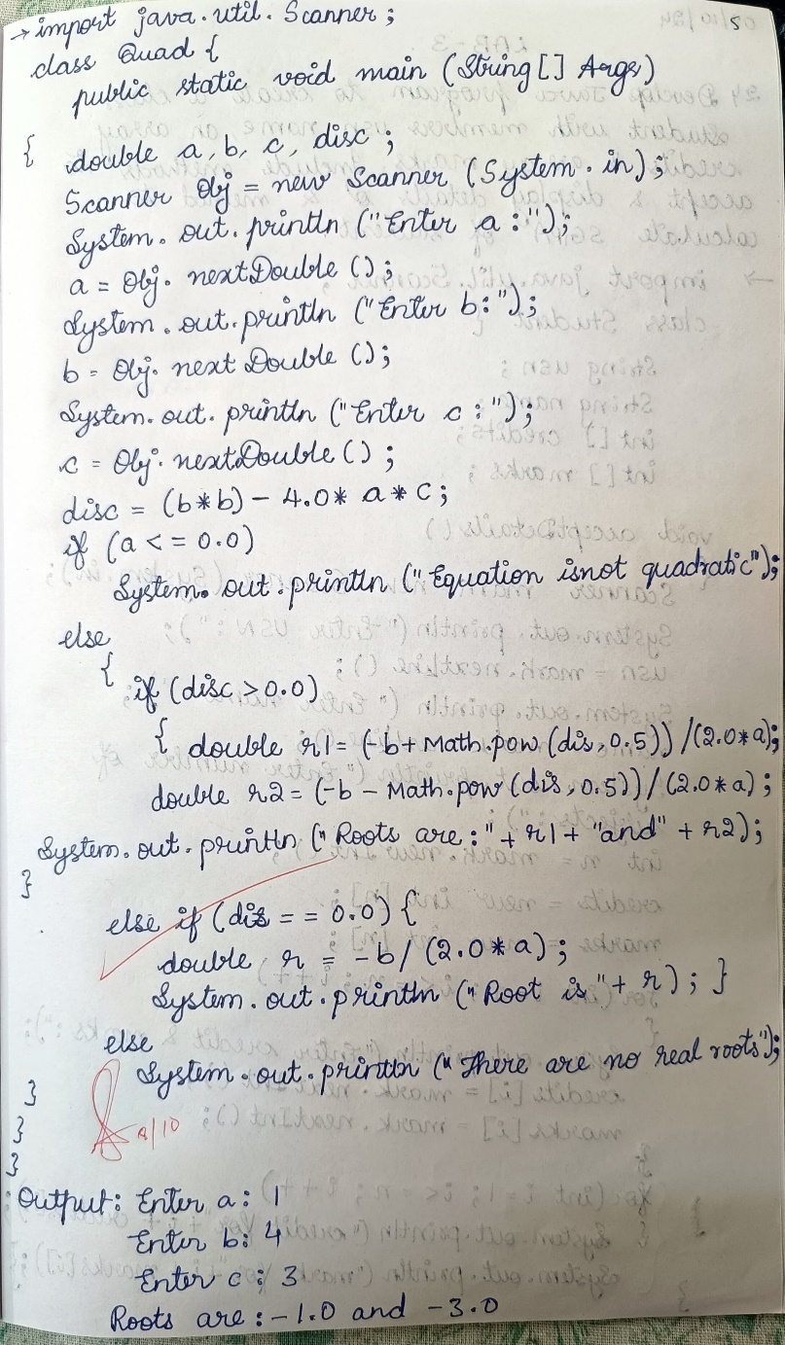

Output:

